TC-REF-008
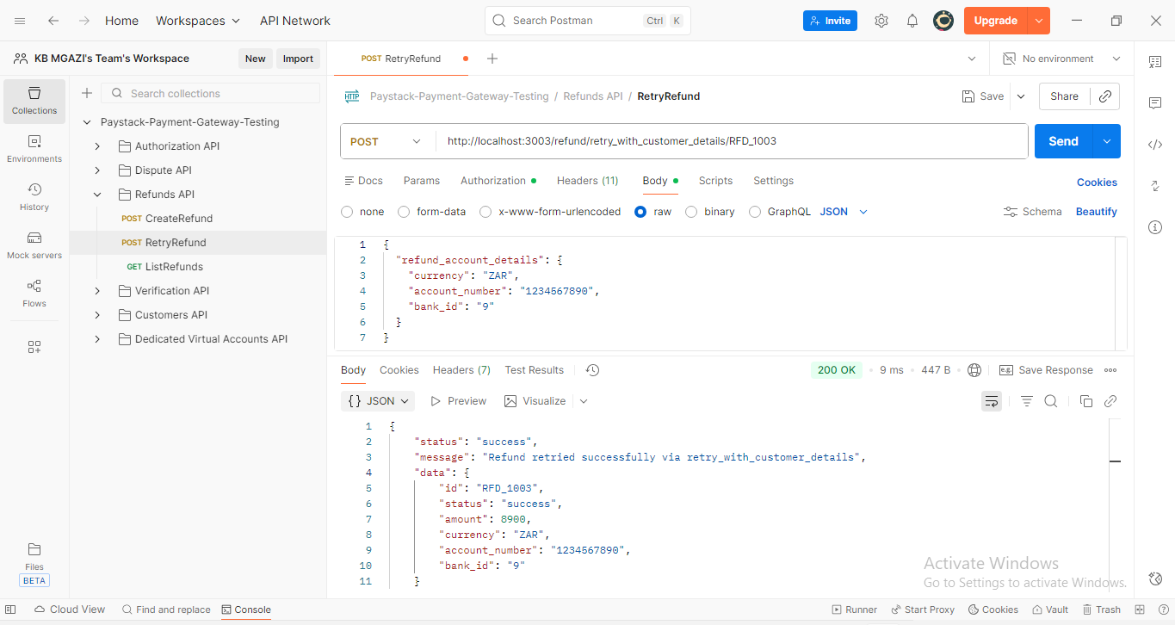
Request:
{
"refund_account_details": {
"currency": "ZAR",
"account_number": "1234567890",
"bank_id": "9"
}
}

Response:
{
"status": "success",
"message": "Refund retried successfully via retry_with_customer_details",
"data": {
"id": "RFD_1003",
"status": "success",
"amount": 8900,
"currency": "ZAR",
"account_number": "1234567890",
"bank_id": "9"
}
}

